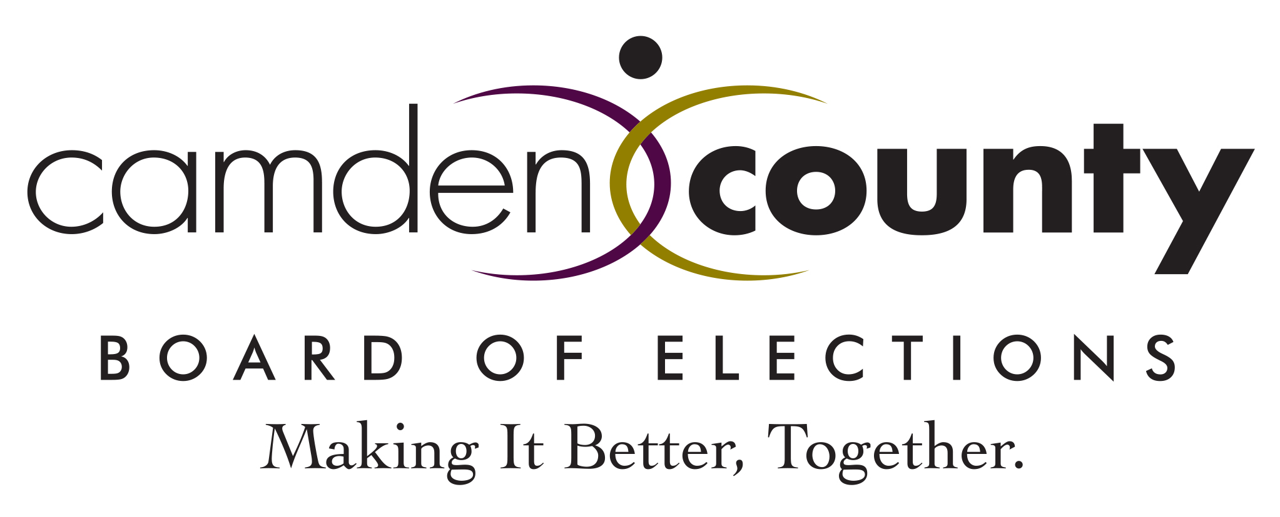

AGENDA BOARD MEETING DATE: NOVEMBER 20, 2024

- Call to Order
- Roll Call: Chair Robinson Taylor, Secretary Ambrosino, Commissioner Hinson, Commissioner Custodio
- Minutes
  - Meeting Minutes of October 16, 2024
  - Audit Ballot Batch Drawing Minutes of November 17, 2024
  - Audit Counting Minutes of November 18, 2024
- Payment of Bills
- Budget Report
- Correspondence - None
7. Old Business
  - Employee Training Chart
  - Polling Place Chart
  - Boardworker Recruitment Update
  - Election Legislation of Interest
7. New Business
8. Public Comments
9. Executive Session
10. Adjournment

